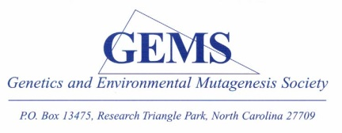
GEMS Spring Meeting
Thursday, May 17th, 2018
EPA (RTP Main Campus)

Understanding Genetic Toxicity and Carcinogenicity Across the Biological Spectrum
Program
8:00 - 8:45 |  | Registration
8:45 - 9:00 |  | Welcome
9:00 - 10:00 |  | In Vitro Hepatocyte/HepaRG Cell Assays as an Alternative to In Vivo Genetic Toxicity Testing
 |  | Leslie Recio, Ph.D., DABT, Integrated Laboratory Systems, RTP
10:00 - 10:15 |  | Coffee Break
10:15 - 11:15 |  | Toxicity Testing of Black Cohosh Extract, a Popular Botanical, at the National Toxicology Program: from Tox21 qHTS Assays to Human Biomonitoring
 |  | Stephanie Smith-Roe, Ph.D., Toxicologist, Biomolecular Screening Branch, National Toxicology Program
11:15 - 11:30 |  | Announcements
11:30 – 12:30 |  | Lunch at EPA Cafeteria
12:30 - 12:45 |  | Brainstorming Session- Membership and Sponsors
12:45 - 1:45 |  | Animal Beacons for Human Health - Canaries in the Coal Mine, Dogs on the Couch.
 |  | Matthew Breen PhD CBiol FRSB, Oscar J. Fletcher Distinguished Professor of Comparative Oncology Genetics, Dept. of Molecular Biomedical Sciences, NCSU
1:45 - 2:45 |  | Metal Genotoxicity and Carcinogenesis in Humans and Wildlife: Gators and Turtles and Whales - Oh My!
 |  | John Pierce Wise, Sr. Ph.D., Professor of Pharmacology and Toxicology and University Scholar, Department of Pharmacology and Toxicology, School of Medicine, University of Louisville
2:45 - 3:00 |  | Closing Remarks

